BCSE308 – COMPUTER NETWORKS

DIGITAL ASSIGNMENT -1

1. Give some advantages and disadvantages of combining the session, presentation, and application layer in the OSI model into one single application layer in the Internet model.
2. For each of the following four networks, discuss the consequences if a connection fails.

a. Five devices arranged in a mesh topology

b. Five devices arranged in a star topology (not counting the hub)

c. Five devices arranged in a bus topology

d. Five devices arranged in a ring topology

1. Find the end-to-end delay (including the transmission delays and propagation delays on each of the three links, but ignoring queueing delays and processing delays) from when the left host begins transmitting the first bit of a packet to the time when the last bit of that packet is received at the server at the right. The speed of light propagation delay on each link is 3x10\*\*8 m/sec. Note that the transmission rates are in Mbps and the link distances are in Km. Assume a packet length of 16000 bits. Give your answer in milliseconds.

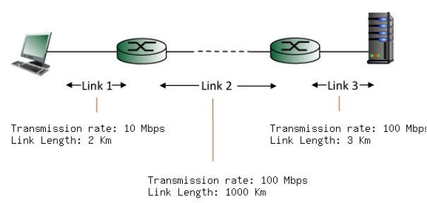

1. A sender needs to send the four data items Ox3456, OxABCC, Ox02BC, and OxEEEE.

Answer the following:

a. Find the checksum at the sender site.

b. Find the checksum at the receiver site if there is no error.

c. Find the checksum at the receiver site if the second data item is changed to

OxABCE.

d. Find the checksum at the receiver site if the second data item is changed to

OxABCE and the third data item is changed to Ox02BA.